Computer Science The GW At Counter Lab Lab Value - 100

Lab Goal : This lab was designed to teach you more object oriented programming and how to write a very simple game using recursion and graphics.

Lab Description : When a mouse-click occurs on a cell that contains an @, count up and remove all @s that are connected up, down, left, and right. Remove the @s that are connected as you count them.

algorithm help

if ( r and c are in bounds and cell is @ )
change cell to -
4 recursive calls up down left right

Sample Output :

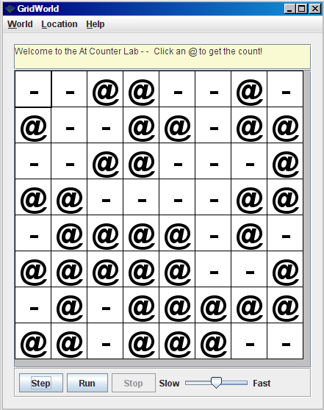

This trash block
contains one cell.
@s about to be counted and removed.

Files Needed ::
AtCounterWorld.java
AtCounterRunner.java

This trash block
contains four cells.

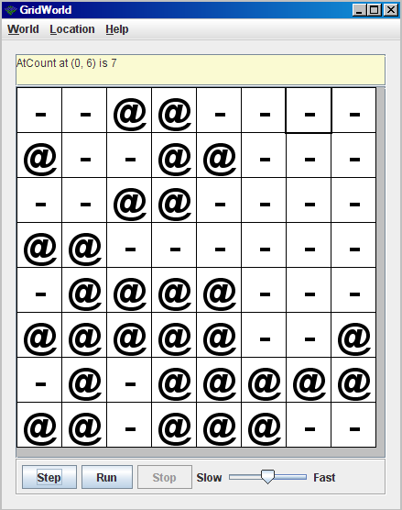
The @s have been removed and counted.

